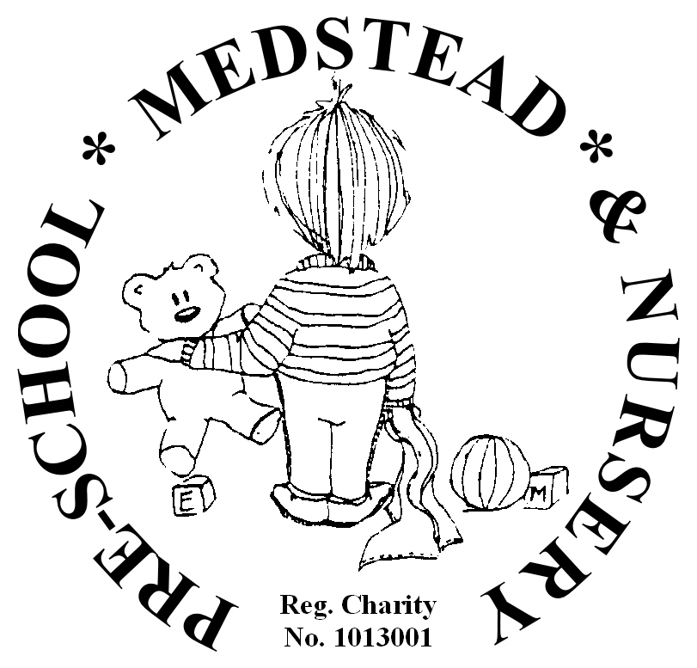

COVID-19 (Coronavirus)

Adjusted Operating Policy Upon Re-opening of Setting

Autumn Term 2020

In response to the continued risk posed to health by Covid-19 (Coronavirus), Medstead Pre-school & Nursery will implement several changes to normal practice upon re-opening in the autumn term.

These changes are temporary but will be in place for as long as it is deemed necessary to ensure the safety of all children, visitors, and staff. Procedures will be reviewed regularly and amended where necessary to reflect updated government guidance and risk assessments.

Whilst we will ensure the safest procedures are in place, we aim to provide as near to normal play opportunities for the children too. All procedures have been carefully planned and risk-assessed to provide the safest space outside of children’s own households to allow them to continue their pre-school journey. Whilst it remains important for adults to practise social distancing, it is recognised that pre-school age children will not be able to do this. A system of controls will be implemented effectively that will create an inherently safer environment. The system of control has two main areas: prevention and response to infection.

Prevention:
- Minimise contact with individuals who are unwell by ensuring that those who have coronavirus (Covid-19) symptoms, or who have someone in their household who does, do not attend settings.
- Clean hands thoroughly more often than usual.
- Ensure good respiratory hygiene by promoting the ‘catch it, kill it, bin it’ approach.
- Introduce enhanced cleaning, including cleaning frequently touched surfaces often using standard products such as detergents and bleach.
- Minimise contact between groups where possible.
- Where necessary, wear appropriate personal protective equipment.

Response to any infection:
- Engage with NHS Track and Trace.
- Manage confirmed cases of coronavirus (Covid-19) amongst the setting community.
- Contain any outbreak by following local health protection team advice.

The changes to policy/measures are as follows,

Entry Refusal & Change to Sickness Policy
Pre-school reserve the right to refuse entry to anyone who appears unwell with symptoms of coronavirus in line with government guidance. Parents are requested to monitor their child’s health carefully and keep them away from the setting if they appear unwell. It is also expected that a child will not attend if someone in their household is displaying symptoms of coronavirus, which now includes loss of smell/taste.

If a child becomes unwell at pre-school, they will be looked after away from the group whilst their parent/guardian is contacted immediately and asked to collect them. In this case it may be necessary for staff dealing directly with the child to wear PPE including gloves, apron, and face mask, until the child is collected. These will be freely available for staff. Anyone who has been in close proximity will need to wash their hands thoroughly for 20 seconds after the child has gone home. Additional cleaning measures will also take place.

Drop Off & Collection
For drop of and collection we will continue to use the school side gate for the foreseeable future. To support social distancing amongst parents, there will be a clearly marked route for dropping off and collecting. Parents MUST maintain 2m distance and a clear queuing system will be in place until we are advised that this is not necessary.
(Appendix 1.)

Pre-school have liaised carefully with Medstead Primary School and will be returning to our normal operating hours. Sessions will be as follows,
Full Day Session 9.05am – 3.05pm
Morning Session 9.05am – 12.05pm
Additional Lunch Hour 12.05pm – 1.05pm
Afternoon Session 12.05pm – 3.05pm

This is subject to change following further government guidance. Parents will be notified of changes as soon as reasonably practicable.

Changes to Early Learner Sessions & Extra Activities
Initially we will not be running external activities such as multi-sports, French, and yoga in line with guidance. This will be reviewed regularly and re-started when it is deemed safe and we have the go-ahead from government. External activities instructors will need to be able to demonstrate effective infection control measures before returning.

Although the pre-school will operate as one ‘bubble’, children will not mix with other bubbles such as school children. Children attending Breakfast Club will be grouped effectively, with table-based activities and toys.

Spending time outside is considered safer than being indoors so we will be utilising our outside space as much as possible to ensure the children can spread out and spend time outside. To engage children more effectively outside, we will be replicating many indoor activities outside to encourage children to play outside.

Personal Hygiene
Good hygiene practices will continually be promoted in the setting with parents asked to support this at home. Pre-school request that all children and adults (parents/carers and staff) wash their hands for the recommended 20 seconds before leaving home and either apply the hand sanitiser provided or wash hands again on arrival at pre-school.
Whilst at pre-school, staff and children will wash their hands for 20 seconds regularly throughout the day. This will include but not limited to; before and after eating/preparing food, after using the toilet, after dealing with any bodily fluid (i.e. wiping noses/changing nappies), when changing rooms in the setting, and before going home. Hand sanitiser / hand wipes will also be available for all adults, and children where parental permission has been given.

Respiratory Hygiene
Children will be encouraged to follow the ‘catch it, bin it, kill it’ approach to ensure good respiratory hygiene.

Enhanced Cleaning Schedule and Infection Control
On top of usual cleaning procedures staff will periodically clean contact surfaces, toys, and equipment throughout the day and the setting will be well ventilated. We will also ensure outside equipment is cleaned carefully and regularly.

Activities such as playdough that could hold germs will be provided but will be changed frequently. Sand and water will also be available but will be changed /disinfected frequently.

We will also follow the recommendations from Public Health England for cleaning of non-healthcare settings.

Personal Protective Equipment
It is currently not recommended for staff to wear Personal Protective Equipment (PPE) beyond what would normally be expected for normal day-to-day running.

NHS Test and Trace
We will follow the NHS Test and Trace procedures and expect staff members and parents/carers to understand that they will need to be ready and willing to:
- book a test if they are displaying symptoms. All children can be tested, including children under 5.
- provide details of anyone they have been in close contact with if they were to test positive for coronavirus (COVID-19) or if asked by NHS Test and Trace
- self-isolate if they have been in close contact with someone who tests positive for coronavirus (COVID-19) symptoms or someone who tests positive for coronavirus (COVID-19)
Anyone who displays symptoms of coronavirus (COVID-19) can and should get a test. Tests can be booked online through the NHS website, or ordered by telephone via NHS 119 for those without access to internet. Essential workers, which includes anyone involved in education or childcare, have priority access to testing.
We expect parents and staff to inform us immediately of the results of the test, but we do not need to see proof of this.
- if someone tests negative, and they feel well and no longer have symptoms similar to coronavirus (COVID-19), they can stop self-isolating. They could still have another virus, such as a cold or flu – in which case it is still best to avoid contact with other people until they are better. Other members of their household can also stop self-isolating.
- if someone tests positive, they should follow Stay at home: guidance for households with possible or confirmed coronavirus (COVID-19) infection and must continue to self-isolate for at least 7 days from the onset of their symptoms and then return to the setting only if they do not have symptoms other than cough or loss of sense of smell or taste. This is because a cough or anosmia can last for several weeks once the infection has gone. The 7-day period starts from the day when they first became ill. If they still have a high temperature, they should keep self-isolating until their temperature returns to normal. Other members of their household should continue self-isolating for the full 14 days.

Managing Cases of Coronavirus
We will take swift action when we become aware that someone who has attended pre-school has tested positive for coronavirus (COVID-19). In this event we will contact the local health protection team. This team will also contact us directly if they become aware that someone who has tested positive for coronavirus (COVID-19) attended the setting – as identified by NHS Test and Trace.
The local health protection team will work with us to carry out a rapid risk assessment to confirm who has been in close contact with the person during the period that they were infectious, and ensure they are asked to self-isolate.
Close contact means:
- direct close contacts - face to face contact with an infected individual for any length of time, within 1 metre, including being coughed on, a face to face conversation, or unprotected physical contact (skin to skin)
- proximity contacts - Extended close contact (within 1-2m for more than 15 minutes) with an infected individual
- travelling in a small vehicle, like a car, with an infected person
The health protection team will provide definitive advice on who must be sent home. To support them in doing so, we will keep a record of:
- children and staff in specific groups/rooms (where applicable)
- close contact that takes places between children and staff in different groups/rooms
We will not share the names or details of people with coronavirus (COVID-19) unless essential to protect others.

Containing an Outbreak
In the event of a local upsurge in infection, we will follow advice and instructions from the Health Protection Team (HPT) in Hampshire.
In some cases, health protection teams may recommend that a larger number of other children self-isolate at home as a precautionary measure – perhaps the whole site or a group. If settings are implementing the controls from this list, addressing the risks they have identified and therefore reducing transmission risks, whole setting closure based on cases within the setting will not generally be necessary, and should not be considered except on the advice of health protection teams

This policy supersedes all others until it is deemed safe to lift the measures. When this happens, the original policies will come back into effect. Parents will be notified of any further changes, and this policy will be updated accordingly.

Signed: Kelly Worthington-Mahmood Date: 06.07.2020
&
Committee

